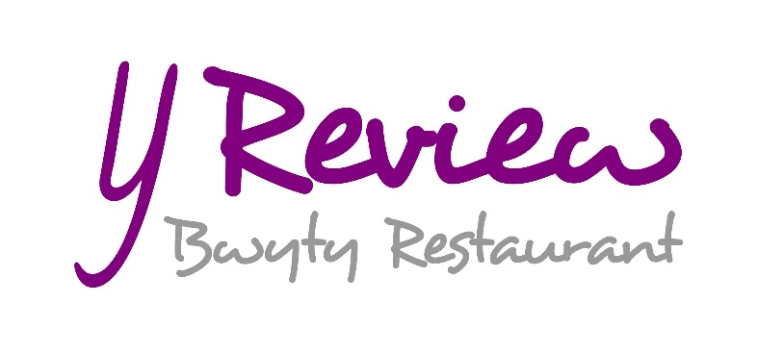
Y Review Menu
Breakfast menu - Served 10.30am -11.30am
All served with tea or coffee
Full breakfast - £9.95
baby sausages, grilled bacon, black pudding, baked tomato, hash brown, baked beans, mushrooms and a choice of scrambled or fried egg. Vegan and Vegetarian options available
Bacon and fried egg bap - £5.95
grilled slices of back bacon with a soft yolk fried egg
Mini Danish pastries - £5.95
2 per person freshly cooked to order, requires 15 minutes
Cob bread toast with a selection of preserves

Lunch menu - Served 12.00pm -14.30pm
Opening Light Bites
- Soup of the day - £5.95
- Falafel with sweet chilli (Ve)- £4.95
- Olives and breads (V) - £4.25
- Baby Sausages with glazed Welsh rarebit - £5.50
- Ham and black pudding fritters (DF) - £5.50
- Prawns with shrimp thermidor - £6.75

For the Matinee l on Mezzaluna Bread or Jacket Potato
(Pickled vegetable, baby salad and classic slaw)
- Flaked tuna with slow cooked red onions and mature cheddar cheese (DF) - £6.75
- Roasted beef and Perl las cheese - £7.25
- Roasted Ham and piccalilli - £6.95
- Breaded king prawns with Katsu curry mayonnaise - £7.25
- BBQ chicken with sweetcorn relish (DF) - £6.75
- Char-grilled courgettes and aubergine mozzarella (Ve) - £6.50
- Goats cheese, sundried tomato and rocket (V) - £6.50

Light Intervals Salads l Starter/Main course size
- Catch of day with poppy seed croutons and lemon and chive dressing (DF) - £5.95/£9.95
- Venue Cymru’s Chargrilled Chicken Caesar salad with baby shrimp - £5.95/£9.95
- Parma ham, buffalo mozzarella and marinated olive salad (GF) - £6.25/£10.25
- Quinoa, pine nut, pomegranate and tofu salad with guacamole and lime dressing (Ve) - £5.75/£9.75

GF- Gluten free V- vegetarian Ve- Vegan DF- Diary Free l All dishes are adaptable for dietary requirements
Main Show l Centre stage
- Beer Battered haddock with chunky chips and minted pea puree - £10.95
- Ratatouille gnocchi with glazed Mozzarella and balsamic reduction (Ve) - £9.95
- ‘Venue Cymru’ Fish finger club sandwich (wholemeal bread, fish goujons, gem lettuce, cucumber, saffron and shrimp tartare) with French fries - £10.25
- Grilled Halloumi with creamed artichoke and buttered pasta (v) (GF) - £10.25
- Soy glazed chicken Chow Mein with sesame seeds and bean sprouts - £11.50
- Baked seabass fillet with spinach , caper and butternut squash risotto - £11.95
- Braised Moroccan shoulder of lamb with spiced vegetable couscous and raita - £16.95
- Butchers platter (braised lamb, 4oz of steak, baby sausages, BBQ chicken fillet with 2 sides of your choice) - £19.95
- Glazed burger Bun with chargrilled chicken, beef or veggie burger with onion rings, gem lettuce, hamburger relish and French fries - £11.95
- 8oz sirloin steak with chunky chips, onion rings with confit cherry tomatoes - £18.95

Side and Extras - £2.75
- Skinny fries/chunky chips/sweet potato fries
- Tossed salad leaves with vinaigrette
- Steamed greens
- Sticky braised red cabbage
- Beer battered onion rings
- Toppings of bacon and cheese or spicy ratatouille
- Classic peppercorn sauce or creamed garlic chestnut mushroom sauce

After Show - £5.95
- Welsh cheeses with gluten free biscuits, chutney and celery salt butter, pickled radish (GF)
- Black forest mousse with cherry and liquorice ice cream
- Pavlova with rosewater poached peaches with toasted almonds (Ve)
- Bara birth and Merlyn pudding with vanilla custard
- Pancakes with maple syrup and lemon curd ice cream
- Ice creams with chocolates soil and caramel sauce

Kids Show - £6.95
Ages 14 and under
- Ham egg and chips
- Fish finger butty
- Quorn or chicken nuggets and chips
- Sausage, chips and beans
Coffee and Cake – Served 14.30pm -16.00pm
GF- Gluten free V- vegetarian Ve- Vegan DF- Diary Free l All dishes are adaptable for dietary requirements

